Foreword
It was an honor and a challenge to write a foreword for this global risk and contingency management in times of crisis book. The challenge stems from the fact that the 16 chapters were written by a score of prominent risk specialists who covered highly diverse risk and uncertainty topics. Additionally, the editors and I were under schedule pressure to make this book project successful. Being an experienced specialist in project risk management (PRM), I did not have much trouble with understanding the logic and value of most of the chapters. However, two chapters that touched on philosophical and futuristic aspects of risk in post-modern Western society were a stunning discovery to me: They harnessed the creative thinking of philosophers, sociologists, fiction writers, and Hollywood moviemakers to shape possible risk-related scenarios of our future.
After reading the abstracts and several chapters, I observed that the COVID-19 pandemic was often – but not always – the underlying crisis for explaining how technical risk management was, or could, be implemented. I applied a semi-structured methodology to categorize the peer-reviewed chapters into the theoretical PRM body of knowledge and then assign an approximate risk frontier coefficient. My methodology was heuristics and perception based, which is often all that a busy project manager may have available when forced to make quick complex decisions with highly variable and verbose business intelligence information. The PRM coefficient roughly classifies documentary evidence into five categories. It covers the entire spectrum of perceived uncertainties from complete risk ignorance to full determinism of uncertainty quantification. I must point out that the book chapters did not fit perfectly into one specific risk frontier coefficient. Therefore, to provide value to the readers, I adapted my methodology to categorize the scientific studies. I assigned a range rather than strictly categorize every chapter. The five PRM frontier coefficients are briefly enumerated below.
- A clear-enough future characterized by slight variations (what we may describe as identifying general uncertainties in PRM);
- A future with alternative outcomes characterized by probabilities (what we may consider to be uncertain events in PRM);
- A few plausible futures requiring routine scenario analyses (these take a form of risk-based and economic-based project alternative decision making in PRM);
- Many plausible futures requiring sophisticated scenario analyses (not used too often in PRM since the basis is often interdisciplinary or abstract factors like politics, policymaking, philosophy, sociology and conceptual studies);
- Deeply unknown futures (in rudimental nomenclature these are often referred to and evaluated in PRM as black swans or unknown-unknowns).
These scales do not represent a good versus bad ranking, but rather, an approximate PRM risk frontier topical coverage. To elaborate further, to categorize information into a PRM frontier coefficient, one must also evaluate the system context as a whole, its scope and parts, its inside interactions, and its external influences. Thus, a PRM frontier coefficient ought to encompass the whole system as well as the level of uncertainty from deeply unknown (5) to clear-enough (1). Strictly speaking, only PRM frontiers 3 – 5 could be described as deep uncertainties in practice. To provide value to the reader, I briefly discuss how each of the 16 chapters correlated to the PRM frontier typology, in terms of two parameters: System as a whole (aka the subject of the study) and uncertainty articulation.
Chapter 1 analyses success of various anti-COVID-19 measures and health campaigns implemented in various countries and observed response patterns (uncertainty types 1 and 3). The undertaken risk analysis explains the divergence in success in battling COVID-19. It is demonstrated that the level of collective citizen trust in government is a significant predictor of effective crisis risk management. It shall be of high interest to UN, WHO and government officials as well as to healthcare workers.
Chapter 2 addresses an important environment protection risk related to oil spill incidents. A novel Bayesian auditing statistical technique has been developed resulting in a predictive probability beta-distribution model as opposed to traditional accident-per-period approach (uncertainty types 1 and 2). This highly efficient statistical technique utilizes random sampling of US oil spill incidents. Besides timely prediction of oil spill incidents, this inferential technique can be applied way beyond oil and gas industry where reliability, availability and maintainability risks are of major concern.
Chapter 3 shares experience of development and implementation of a new maturity model for risk management at a German automotive plant. The developed model has been used to deploy cloud-based enterprise risk system and to manage a product development program. This handles uncertainty types 1 and 2 in the automotive industry. Besides automotive risk and project managers this chapter should be of interest to risk specialists in other production industries.
Chapter 4 investigates effects of bubbles and causality among bitcoin, gold and oil markets based on price dynamics from July 2010 to September 2021 (uncertainty types 1 and 2). The working hypotheses have been tried using generalized supremum augmented Dickey-Fuller (GSADF) statistical test resulting in a conclusion that there is a significant evidence of bubble explosive behaviors in the bitcoin and oil prices, but not in the gold prices, mostly in periods of quantitative easing and financial stress. It should be of interest to investment, fintech, banking, etc. specialists.
Chapter 5 marries lean six sigma risk management with social and corporate responsibility initiatives aimed at climate conservation and clean energy production at a hydroelectricity generation plant in the State of New York, USA (uncertainty types 1 and 2). This methodology zeroes in on prevention of various man-made accidental disasters. A statistical six-sigma-process-control model was developed using inspection data to support this methodology. No doubts that this chapter would be highly appreciated by representatives of energy production facilities – both renewable and traditional – and any other corporations supporting clean energy initiatives.
Chapter 6 investigates one of the main risks encountered by businesses these days across the Globe – supply chain logistics vulnerability – which is one of core root causes of structural inflation (uncertainty types 1 – 3). This study delves into Global Supply Chain Forum (GSCF) fundamental processes. Although specifically it aims at Nigerian supply chain logistics impacted by COVID-19 pandemic. This chapter verifies ways to strengthen logistics operations and business resilience. It could be of interest to logistics specialists especially in the light of upcoming impacts of sanctions.
Chapter 7 is devoted to contribution of information technology industry of India in development of risk assessment tools (uncertainty types 1 – 3). It shall be of interest to risk management and organizational effectiveness specialists responsible for deployment of enterprise risk management systems in various industries – from banking and insurance to engineering, to education, to marketing.
Chapter 8 introduces risks associated with implementation of blockchain technology that may occur among telecommunication carriers (VOIP providers). Namely, transparent storage of Call Detail Records (CDRs) when exchanging calls might fail resulting in billing discrepancies, disputes, and interruption of services (uncertainty types 1 and 2). The authors come up with a permission blockchain business model architecture for VOIP providers based on hyper-ledger fabric to support smart contacts which allows reliable CDR storage. This chapter addressing the blockchain technology risk should be of high interest to blockchain, fintech, banking and IT specialists.
Chapter 9 sheds light on cyber security risk management in various industry sectors. It covers overall cyber security risk management system as well as specific risks such as increasing number of cyber-attacks during the COVID-19 pandemic (uncertainty types 1 and 2). This chapter should be of interest to risk management specialists who deal with cyber security risks in various industries.
Chapter 10 describes developments in healthcare informatics in times of COVID-19 pandemic as healthcare organizations have undergone real “stress tests” (uncertainty types 1 – 3). It shows how healthcare informatics allows mitigate healthcare challenges (e.g., treating of patients remotely, reducing exposure of personnel to COVID-19, etc.) through using telemedicine, drug delivery portals, drones, robots, big data, AI, etc. It shall be of lively interest to many healthcare professionals.
Chapter 11 reviews risks and challenges of big-data analytics implementation in fifty Indian enterprises (uncertainty types 1 and 2). This study has discovered five risks related to lack of human resources, data privacy and security, shortage of technological resources, deficiency of awareness and financial constraints. This chapter should be of keen interest to many corporate IT specialists.
Chapter 12 is devoted to organizational risks preventing professional growth of female employees in banking, education, government, etc. sectors of United Arab Emirates (UAE) during COVID-19 pandemic (uncertainty types 1 and 2). Collected survey data have been processed statistically. A resulting conclusion points to the fact that the discussed risks have a high impact on women's professional development and their mindsets. This chapter shall be of interest to corporate, government and non-government policymakers involved in handling of diversity factors.
Chapter 13 discusses COVID-19 impact on education in Ethiopia resulting in educational process disruption and inequality. It also points to ways to mitigate the impact (uncertainty types 1 - 3). It should be of interest to policymakers dealing with education programs – from UN to developing-country government officials – as well as to teachers and students.
Chapter 14 puts forward risks that may be encountered by Canadian residential real-estate investors (uncertainty types 1 – 3). Major mitigation measures are discussed to ensure wealth growth through real estate business by averting pertaining risks both prior to and after buying an investment property. It shall be of interest to North American, European, and Australian real-estate investors.
Chapter 15 presents a sociological study that investigates reasons why the Western society moves from traditional and more rational perception of risk (tabbed as “Risk Capitalism”) to a way more emotional perception based on fear (tabbed as “Thana Capitalism”). A role of some epoch events like Chernobyl disaster and COVID-19 pandemic in this shift is thought through. Development of scenarios of “futures” utilizes review of dystopian novel and movie The Hunger Games: it is believed by the author that this novel and the movie represent perfectly how the “Thana-Capitalism” would work. Again, the same as chapter 16, chapter 15 utilizes intuitive scenario-building approach to shape “futures” (uncertainty types 3 – 5) and should be attractive to many people interested in futuristic risk studies.
Chapter 16, which could be considered a spin-off from chapter 15, was perceived as rather unconventional by typical representatives of enterprise, project, operations, etc. Honestly, it has been a double-taker to me as it prescribes deep shifts and associated risks occurring in the Western society after 9/11. Rather sensitive general topics related to “non-Western others” are discussed including specific implications for hospitality industry. Moreover, this chapter deals with futuristic post-modern Western society through analyzing a dystopian world introduced by the HBO Saga, Westworld as an object for philosophical thinking. This chapter points to an intrinsic value of artistic and philosophical intuitive approach for development of scenarios of “futures” (uncertainty types 3 – 5). It could be of curious interest to a broad auditorium.
This book being an impressive teamwork of the chapter authors and editors shall be well received by risk management professionals and decision makers working in various sectors from healthcare and cyber security to education, to operations, to finances.

Yuri Raydugin, Risk Services & Solutions Inc., Calgary, Alberta, Canada
yuri.raydugin@risk-service.com

Dr Yuri Raydugin is Principal Consultant of Risk Services & Solution Inc, a Canadian consulting company. Previously, Yuri worked for Saudi Aramco, Royal Dutch Shell, TransCanada Pipelines, and SNC-Lavalin. He has been involved in risk management of capital mega and large projects with combined budget of more than $160B. Yuri has an engineering degree in nuclear physics from Urals Polytechnics Institute, Russia, a PhD in physics and mathematics from Russia's Academy of Sciences, and an MBA in business strategy from Henley Management College in England. He is a member of the Association of Professional Engineers and Geoscientists of Alberta (APEGA).
Yuri is an author of several articles on project risk management as well as on various aspects of physics. He is the author of ’Modern Risk Quantification in Complex Projects: Non-linear Monte Carlo and System Dynamics Methodologies’, Oxford University Press (2020) and 'Project Risk Management: Essential Methods for Project Teams and Decision Makers’, John Wiley & Sons (2013) as well as the editor of 'The Handbook of Research on Leveraging Risk and Uncertainties for Effective Project Management', IGI Global (2017). Born and raised in Ekaterinburg, Russia, Yuri lives and works in Calgary, Alberta, Canada.

Preface

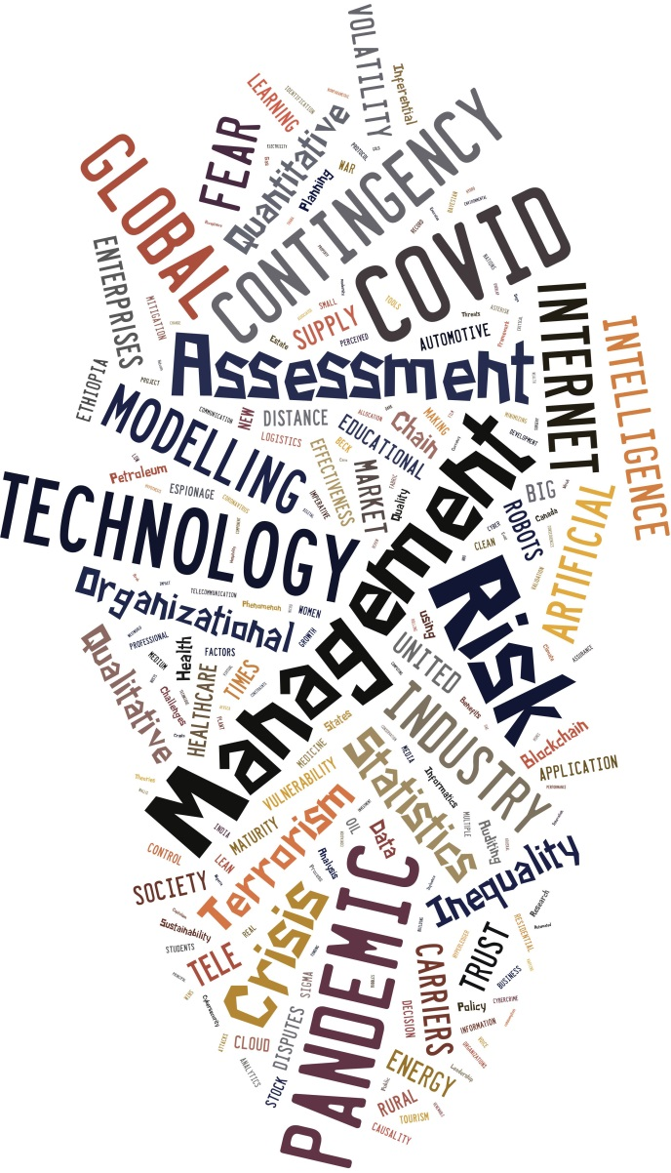
INTRODUCTION
This book explores selected risk and contingency management topics in a crisis, including fear, artificial intelligence, healthcare pandemic, political instability, big data, internet terrorism, and others, as illustrated in figure 1. The editors created the thematic diagram using empirical evidence. The keywords and abstracts of the manuscripts from 21 subject matter expert authors across 10 countries were tabulated into frequencies and graphically modeled using font size to represent a percentage of reiteration (larger words indicate higher interpreted importance). Even more interesting is the post-hoc thematic model of the analysis for the entire book contents (discussed later). This initiative is an empirical extension of our previous project, which was focused on theoretical risk models (Strang, Korstanje, Vajjhala, 2018). This book focuses on how risk and contingency management were retrospectively applied by practitioners in a crisis, namely the COVID-19 pandemic, environmental conservation, climate control, economic volatility, healthcare supply chain constraints, internet cyber-security terrorism, inequality, and global political instability.
Figure 1. Thematic Topic and Keyword Coverage
The intended audience for this book includes risk management practitioners and academics across numerous disciplines and industries. Most of the subject matter experts were academics and scholars with preexisting peer-reviewed publications. Still, selected contributors were specialists in economics, politics, social policy, terrorism, cryptocurrency, and statistical modeling. The industries included healthcare, financial ‘fintech’, oil and gas refining, automotive manufacturing, clean energy creation, hydroelectricity, education, engineering, internet cyber-security, artificial intelligence robots, big data analytics, tourism, real estate investment, and supply chain management. Clearly, the stakeholders for this book are decision-makers, practitioners, and researchers. Students, academic teachers, librarians, politicians, and content writers may also be interested in this. Therefore, this book ought to help instructors, undergraduate and post-graduate students by providing vital case studies in understanding how the organizations deal with a crisis.
This book could also be described as retrospective science since the authors often revisited recent studies and extended their findings or models based on actual pandemic experiences. Earlier projects may have been focused on disciplinary topics such as healthcare or education. In contrast, in this book, prior studies were expanded to collect data and or interpretations of how risk and contingency management was applied during a crisis. The Covid-19 coronavirus pandemic was typically the crisis scenario underpinning most of the book chapters. Yet, some researchers focused on other salient contexts, such as environmental conservation, economic sustainability, and global terrorism, including artificial intelligence, cyber-security, and big data risk management.

BOOK RATIONALE AND PROJECT MANAGEMENT METHODOLOGY
The rationale for creating this book was primarily to address the coronavirus pandemic, yet other issues also came to light. First, the definition of risk was grounded in the a priori literature. Risks can be identified, evaluated, mitigated, and evaluated, but the underlying uncertainty remains elusive yet always present across most industries (Strang, 2015; Strang, Korstanje & Vajjhala, 2018). This is why the topic needs to be iteratively researched. The editors extended the 2018 project to encompass new findings over the last 4-5 years after the coronavirus pandemic and global instability.
This book project finished approximately 6 months ahead of schedule, it was under budget, within agreed-upon scope and at acceptable quality levels. The project management was shared between Vajjhala and Strang. All chapters were double-blind peer-reviewed, with Vajjhala serving as the managing editor since Strang contributed two chapters. The initial design was created by Strang, while Vajjhala managed the book editing and peer reviews. The preface chapter summary was written by Vajjhala and completed by Strang, including the statistical analysis of the keywords. The foreword was initiated by Strang and written independently by a global risk management expert and scholar, Dr. Yuri Raydugin. Both editors received ethical approval to conduct this project, and no specific external funding was received. No conflicts of interest were reported. In other words, the primary motive for the editors underpinning this book was to advance the state-of-the-art in risk contingency management through collaboration as well as knowledge sharing. A secondary motive of the editors was to stimulate empirical and qualitative case study research on these topics.

CHAPTER OVERVIEW
In Chapter 1 - In Crisis Risk Management Across Nations, COVID-19 Wins When Trust is Low, Colin Read contrasts the outcomes of the COVID-19 pandemic based on their response patterns, delving into the research on successful contingency and risk management to understand the disparity in pandemic success. According to the author, leaders who closely followed the advice of public health professionals performed better in terms of illness mitigation and economic displacement. The author successfully establishes that citizen trust in government is an essential predictor of good crisis risk management.
In Chapter 2 - Petroleum Industry Contingency Planning using Auditing Theories and Inferential Statistics, Kenneth David Strang shows how to forecast petroleum accidents using a unique Bayesian auditing statistical technique combined with a predictive probability distribution model. The author develops petroleum oil leak patterns for a particular population, creates a predicted distribution model, and validates it using Bayesian audit statistical techniques in this chapter. The author used fixed interval random sampling to choose records for the audit using sample data from a state in the United States. The author demonstrated the materiality parameters and misstatement results using a beta distribution.
In Chapter 3 - Development and Application of a New Maturity Model for Risk Management in the Automotive Industry, Jose Irizar and Martin George Wynn explain and explore a new maturity model for project risk assessment and management in the automotive industry. The authors offer a case study analysis conducted in a major German automotive firm to develop a maturity model utilizing a qualitative and inductive approach based on data from in-depth interviews. The authors then apply this approach to two significant projects now underway at the company: one involving adopting a cloud-based ERP system and the other involving the product development and launch program management function. By establishing a new model particular to the automobile industry, the authors contribute to existing risk management maturity models. Risk and project managers can apply this model to other sectors as well.
In Chapter 4 - Does Contagion Effect of Bubbles and Causality Exist among Bitcoin, Gold, and Oil Markets?, Remzi Gök investigates the explosive behaviors, causation linkages, and contagion effects amongst three financial markets utilizing daily closing prices of Bitcoin, gold, and West Texas Intermediate (WTI) oil prices for a sample period of July 19, 2010, to September 10, 2021. The author used the Generalized Supremum Augmented Dickey-Fuller technique to discover considerable evidence of bubble explosive behaviors in Bitcoin and WTI prices—but not in gold prices—during periods of quantitative easing and financial stress. The author states that no evidence is available for the contagion effect of bubbles between cryptocurrency and oil markets during the sample period.
In Chapter 5 - How Lean Six Sigma Risk Management was used at a Clean Energy Plant?, Kenneth David Strang investigates how lean six sigma quality ideas were used to manage risk in a renewable energy hydroelectricity facility. Through quality inspections, the author gathered data from a plant in New York, USA. The author designs a statistical process control model based on attribute and continuous inspection data. Because of the potential for substantial man-made unintended disasters, if specific crucial processes fall out of control, the author contends that advanced quality management techniques are required to properly and safely operate any form of energy generation plant.
In Chapter 6 - Supply Chain Logistics Risk Mitigation - Impact of Covid-19 Pandemic, Edna Denga and Sandip Rakshit perform an empirical analysis in the Nigerian supply chain logistics setting to examine and compare the uncertainties, tactics, and strategies used by two enterprises in Nigeria's northeastern region. The authors concentrate on Nigeria's northeastern part, where insurgency and banditry are common, and the recent COVID-19 pandemic has aggravated the situation. The writers take a theoretical approach to logistics and supply chain management, diving into the global supply chain forum's key business processes and logistics functions in each highlighted industry. The findings of this study are relevant because supply chain resilience and risk management are becoming more visible in the post-pandemic environment as businesses try to increase their operations and company resilience.
In Chapter 7 - Risk Assessment in Information Technology Industry- An Imperative Phenomenon, Madhu Kishore Raghunath and Tulasi Devi investigate the effects of qualitative, quantitative, and hybrid risk assessment tools on organizational effectiveness, considering the perceived advantages in the Indian information technology industry. In this chapter, the authors show how risk-based decisions become more plausible when they are made using risk assessment tools available to corporate organizations. The authors argue that the opportunity is greater than the risk, encouraging individuals and businesses to take prudent risks.
In Chapter 8 - Minimizing Risk of Disputes among Telecommunication Carriers with Blockchain Technologies, Evis Trandifili, Marenglen Biba, and Enes Cela study the use of permissioned blockchain in the business model of telecommunication carriers. The authors propose a business model architecture for the generation of smart contracts based on hyperledger fabric, which stores information about each call detail record generated and business cases. The authors outline the methods and configurations required to integrate the various technologies and create a development network. The authors provide the findings of performance tests related to transaction submission latency.
In Chapter 9 - Cybersecurity Risk: Assessment and Management, Natasha Cecilia Edeh and Ibiene Idu present a comprehensive overview of cybersecurity risk. The writers provide an overview of cybersecurity, vulnerabilities, frequent cyber threats/attacks, and why cybersecurity risk is crucial to businesses. The authors discuss cybersecurity threats in several industries and provide an overview of the multiple cyber-attacks during the covid-19 outbreak. The authors discuss the role of organizations in the handling and management of cybersecurity risks and the activities that governments, organizations, stakeholders, and individuals should take to minimize or manage cybersecurity risks.
In Chapter 10 - Healthcare Informatics during the Covid 19 Pandemic, Philip Eappen examines how healthcare companies used innovative healthcare informatics during the pandemic and how technology assisted in reducing healthcare delivery issues. The author discusses a variety of healthcare informatics applications that have been developed and utilized around the world, including telemedicine, drug delivery portals, drones, robots, big data, artificial intelligence, and a variety of other complex applications for remote patient care. The author also discusses different health informatics methods, such as telemedicine, that have helped healthcare staff avoid needless contact with contagious patients, averting numerous illnesses in hospitals.
In Chapter 11 - Consequences in Acceptance and Application of Big Data Analytics in Micro, Small & Medium Enterprises in India, Rajasekhara Mouly Potluri explains the implications of accepting and using big data analytics in India's micro, small, and medium enterprises (MSMEs). The author presented conclusions based on experimental evidence on five critical problems that Indian MSMEs experience in accepting and implementing big data analytics: a lack of human resources, data privacy and security, a lack of technological resources, a lack of knowledge, and financial consequences. The author conducted research using various methods to collect responses from middle and top-level managers in fifty firms across five key commercial sectors. The outcomes of this study should aid MSMEs' organizational leadership in developing and planning short- and long-term information systems strategies.
In Chapter 12 - Risks Associated with Organizational Factors Influence on the UAE Women's Professional Growth During Covid-19, Rajasekhara Mouly Potluri and Sophia Johnson explore the risks associated with organizational factors influencing the professional growth of women in the United Arab Emirates (UAE) during the pandemic. The authors identified that organizational and situational factors have a high degree of impact on women's professional development, which creates a significant effect of discontent over the mindset of women employees even in uncertain conditions. This chapter covers women employees working only in two emirates, Dubai and Sharjah. This book chapter is valuable to all the policymakers of the entire corporate sector and government authorities to set the right things by observing diverse organizational factors that influence women employees.
In Chapter 13 - COVID-19 Pandemic, Distance Learning and Educational Inequality in Rural Ethiopia, Degwale Gebeyehu Belay explores the educational inequality of rural students of Ethiopia using situational analysis. The findings of this chapter unveil the multiple inequalities of rural students that make them in a disadvantaged position compared to urban students. The author posits that the available distance learning programs homogenize students creating educational disparities. The author presents the strategies used by the Ethiopian Ministry of Education to avoid the disruption of learning during the pandemic. The plan included radio and TV education programs designed for primary education, TV programs for secondary education, and online teaching for higher education.
In Chapter 14 - Managing Risk in Wealth Building through Residential Real Estate Business in Canada, Mahendra Singh Rawat and Mudit Rawat discuss the risks of investing in residential real estate in Canada. The authors claim that discussing just domestic real estate is crucial since residential real estate contributes significantly to household income and takes less capital to operate and develop wealth in comparison to commercial real estate. The authors discuss the hazards that an investor encounters when managing rental properties. This chapter explains how to avoid specific hazards before and after purchasing an investment property. The chapter emphasizes the importance of buying the right property at the right time and in the right location.
In Chapter 15 - From the Risk Society to COVID-19: Analysis of the Beck´s Risk Society: Towards a New Modernity, Maximiliano Emanuel Korstanje introduces readers to Thana Capitalism's intellectual foundations, as discussed in the book -"The Rise of Thana Capitalism and Tourism". Ulrich Beck, a German sociologist, defined risk society as a new developing ethos in which social class and hierarchies blurred in the face of risk. Beyond the recent COVID-19 outbreak, the author observes the relationship between Thana capitalism and spectacle.
In the book's final chapter - Terrorism, Automated hosts and COVID-19: critical Film Review on HBO Saga, Westworld, Maximiliano Emanuel Korstanje discusses the HBO series Westworld, which depicts a futuristic and dystopian society in which robots (hosts) are exposed to torture, violence, and even sadistic activities at the hands of wealthy tourists (guests). The author examines the argument in "Robots We Must Trust" through a critical lens. The author claims that the reign of terror sparked by 9/11 and the subsequent War on Terror have hastened the social imaginary's consequences. Beyond the economic fallout, the author claims that 9/11 re-created the circumstances for a monopoly of politicized rhetoric aimed primarily at demonizing the "Non-Western Other."
SYNOPSIS AND FUTURE RESEARCH
In this subsection, we, the editors, take the unusual approach of ending the book with no summary chapter, electing instead to ask the readers to conduct literature reviews to identify topics important to key stakeholders. Instead of a summary chapter, the editors present a visual synopsis of the themes emerging from the full manuscripts, a post-hoc empirical analysis of the thematic concepts in figure 1. This ought to summarize which topics from figure 1 were reiterated in the subject matter expert case studies. This summary is presented in figure 2, an empirical risk contingency management synopsis. Therefore, figure 2 extends figure 1 with what was discussed and or modeled by the authors of this book. We argue these topics were the most important keywords in the risk contingency management discipline during a crisis, particularly (but not limited to) the global coronavirus pandemic of 2019-2022. Figure 2 was developed in a similar methodology as figure 1 by tallying the frequencies of keywords and creating a graph where the size of the word reflects the importance (frequency) of the topic discussed by the book authors.
It is interesting to note from figure 2, as contrasted with figure 1, that new topics arose in perceived importance, namely, real estate, cyber-security, healthcare assessment, artificial intelligence, robots, statistical models, capitalism, and social concerns. Without question, much of the emphasis was on technology, healthcare, covid-19 pandemic, effective business decision-making processes, and data analytics.
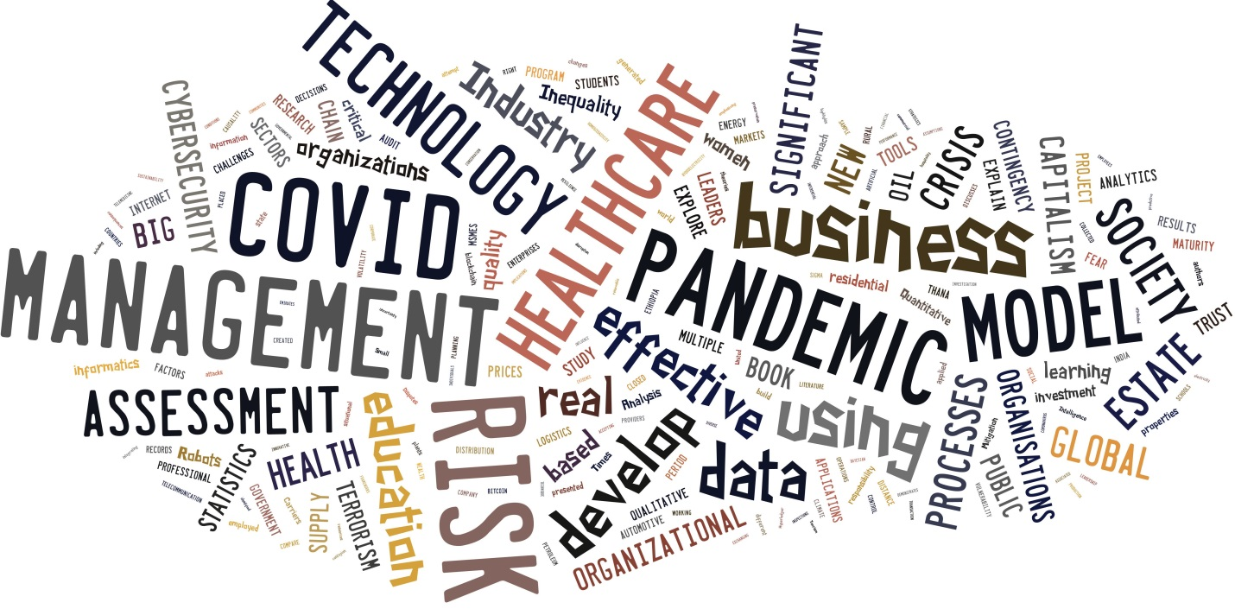
Figure 2. Post-Hoc Keyword Synopsis Model

Based on the keyword synopsis model, the editors assert that state-of-the-art risk and contingency management coverage pertain to health and financial related crises. In the future, we argue more empirical and experimental research is needed to understand how decision makers and consumers will react to risks. We base this proposal on the fact that most nations globally have democratic political governance, so citizens have much more power compared to decades ago. Now with ‘we the people’ influencing national policies and organizational cultures, we anticipate a very different future world. We argue more consideration will be given to people rather than political pundits or leaders. We argue that risks such as man-made terrorism or wars could be reduced with better strategic management of politics and global relationships. We also argue that natural disasters and risks, including pandemics and climate warming, need to be addressed immediately at the highest level of authority; otherwise, the next book we will be writing may be focused on how decision-makers are handling the global apocalypse and evacuation to other planets.

REFERENCES
Strang, K. D. (2015). Risk Management Research. In IRMA (Ed.), Research Methods: Concepts, Methodologies, Tools, and Applications (Vol. 2, ch 17, pp. 362-389, 978-1466674561). Hershey, PA: Information Resource Management Association (IRMA). doi:10.4018/978-1-4666-7456-1.ch017
Strang, K. D., Vajjhala, N. R., & Korstanje, M. E. (2018). Global risk and contingency management overview. In K. D. Strang & M. E. Korstanje & N. R. Vajjhala (Eds.), Research, Practices, and Innovations in Global Risk and Contingency Management (pp. xxii-xxix). ISBN: 978-1522547549. PA: IGI-Global. doi:1522547510.1522544018
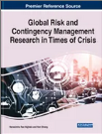
Vajjhala, R., & Strang, K. D. (Eds.). (2022). Global Risk and Contingency Management Research in Times of Crisis (340 pp.). Hershey, PA: IGI Global. doi:10.4018/978-1-6684-5279-0 https://www.igi-global.com/book/global-risk-contingency-management-research/294858

Editors
Associate Professor Narasimha Rao Vajjhala, Phd, MSCS, MBA, AS, PMP
University of New York Tirana, Albania
Dr. Narasimha Rao Vajjhala is working as an Associate Professor and the Chair of the Information Systems department at the American University of Nigeria. He had previously worked at the Faculty of Engineering and Architecture at the University of New York Tirana, Albania. He is a senior member of ACM and IEEE. He is the Editor-in-Chief for the International Journal of Risk and Contingency Management, and a former Managing Editor. He is a member of the Risk Management Society, and the Project Management Institute. He has over 20 years of experience in teaching programming, design, security, analytics and database-related courses at both graduate and undergraduate levels in Europe and Africa. He has also worked as a consultant in technology firms in Europe and has experience participating in EU-funded projects. He has completed a Doctorate in Information Systems and Technology (United States); he holds a Master of Science in Computer Science and Applications (India), and a Master of Business Administration with a specialization in Information Systems (Switzerland).

Professor Kenneth David Strang, Doctorate, MBA, BS, AS, CNA, CSCS, CRP, CPP, FLMI, PMP
W3-Research, USA and RMIT University, Australia
Professor Strang has almost 300 publications (http://kennethstrang.com) and at the time of writing he has consistently ranked in the 95-97 percentiles of world-wide scholars at Research Gate. Dr. Strang has been working since 1983. Ken has been employed by W3-Research, a business analytics company, since 2010. He is a retired full professor who occasionally lectures at reputable universities and associations. Ken has a professional Doctorate in project management operations research, an MBA in strategic management, a BS in marketing, and an AS in computer science all with summa cum lade high grade distinctions. He has six professional certification/licenses: Certified Netware Administer (security), a Fellow Life Management Institute (insurance actuary), a Certified Research Professional (scientific research), a Project Management Professional, a Certified Supply Chain Specialist/Procurement Professional, and a World Medical Association research ethics certification. Ken conducts research in business, healthcare, logistics/supply chain, manufacturing, marketing, mining, new product development, leadership, organizational behavior, industrial psychology, tourism marketing, human resource management, learning styles, online learning, nuclear-hydro-solar-wind clean energy production, and procurement project management. He edited a best-selling research design-methods textbook for Palgrave-Springer and he won over $8M USD in grant-proposals to support his clients. He also won two Emerald Literati Awards. He has managed over 115 studies, taught over 1000 multicultural students with an anonymous course opinion survey satisfaction median of 5/5 and a mean of 4.5/5. Ken volunteers for many charities and not-for-profit social advocate associations.

